Spring Security intercepts all the requests coming in. There's a filter chain that you can configure, and this filter chain would intercept all the requests that are coming in.
And only after spring security checks, authentication, and authorization.
Then the request is sent to dispatch servlet and for further processing to the controllers.

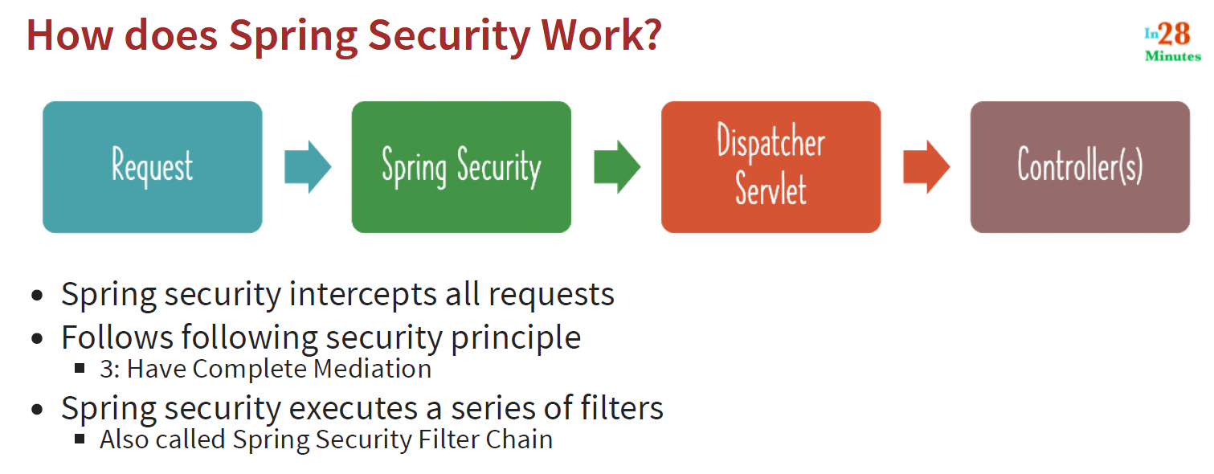
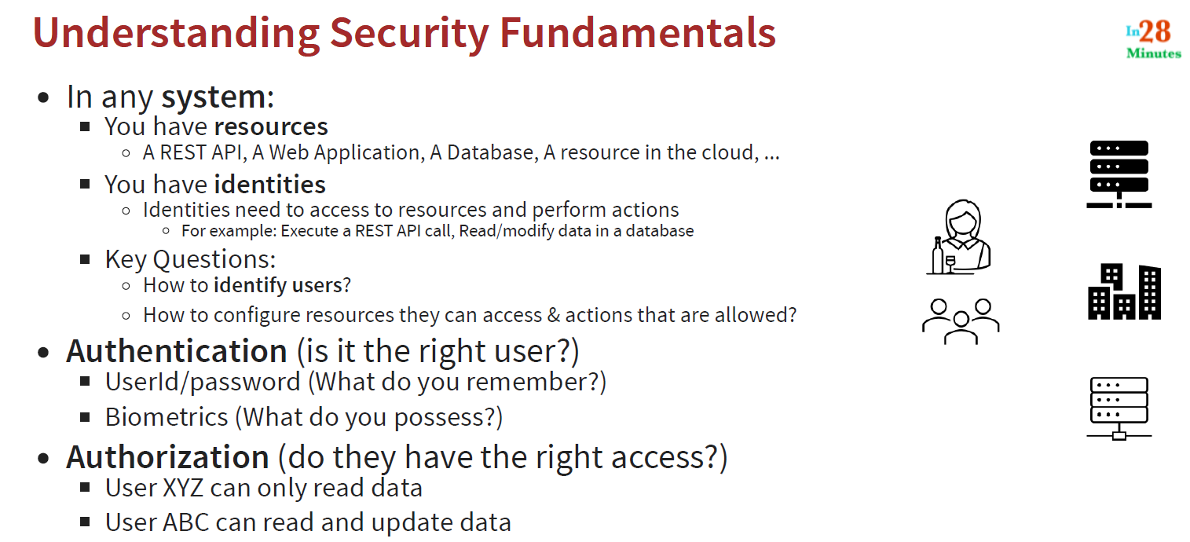
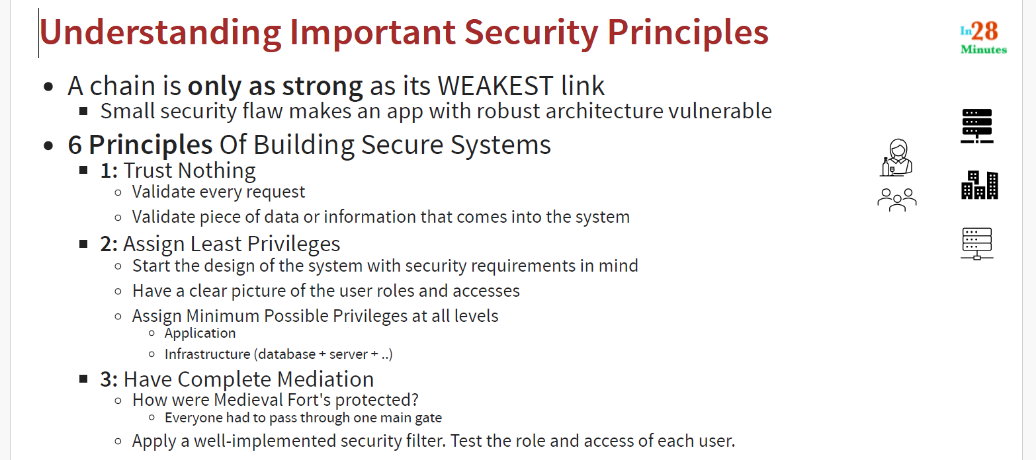
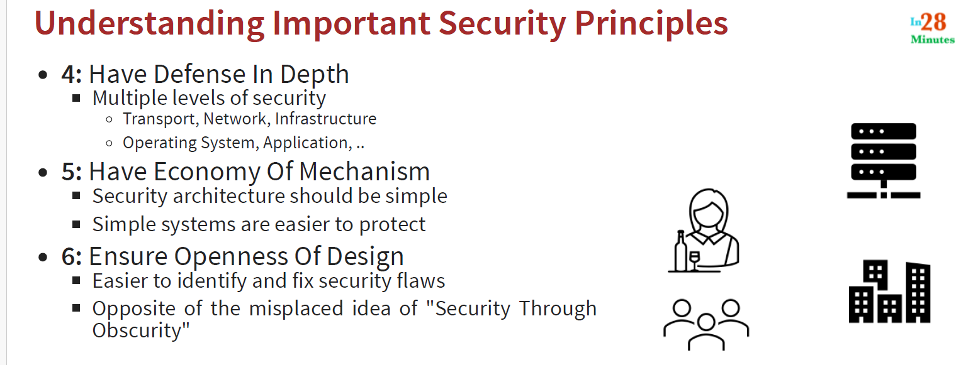

CSRF cross-site request forgery.

Typically, a user session is created for you, once you log into a website and a user session is typically identified by using a cookie in your browser.
If you don't log out of that specific website and you go into a malicious website, the malicious website can make use of the previous authentication that you have. The cookie which is present in your browser.
This vulnerability is called CSR or cross-site request forgery.
And when you add in spring security, CSRF protection is automatically enabled for any update requests for post, put, etc. for all these CSR if protection is enabled.

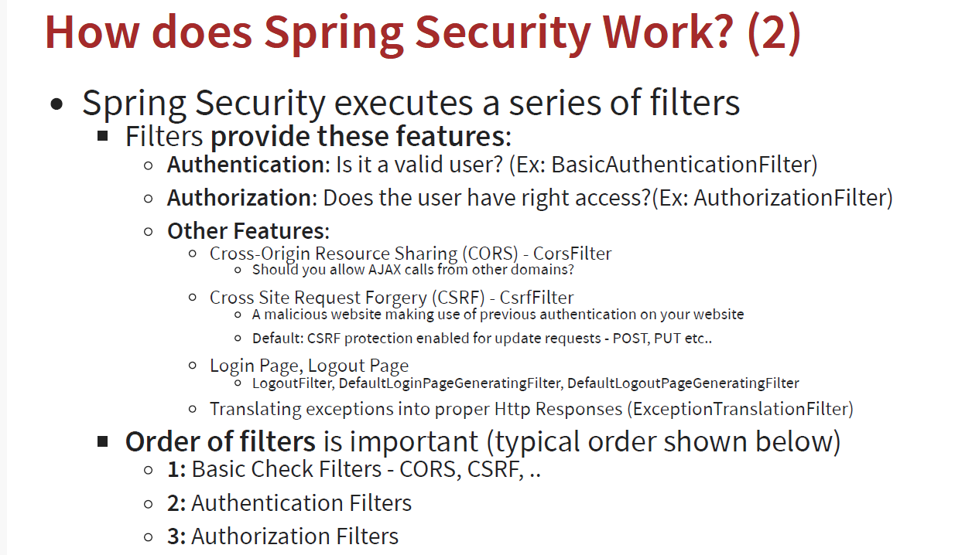

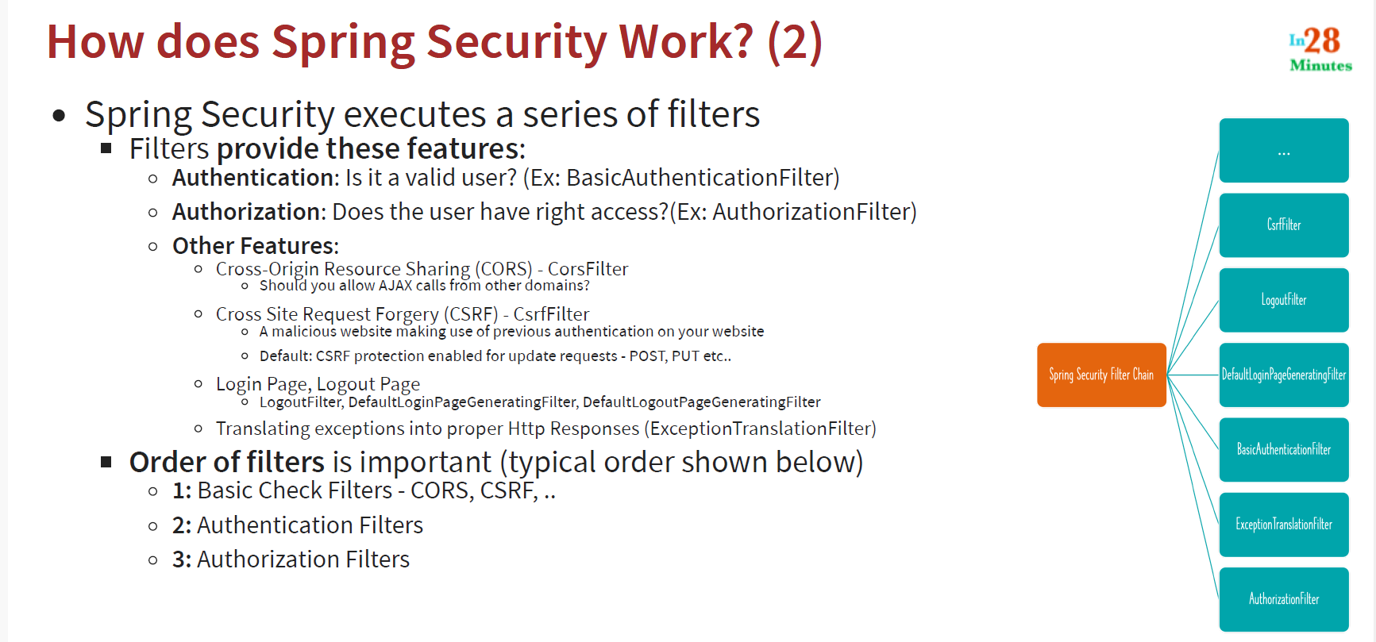
The order of execution of the filters is very, very important.
The first thing that would be checked is the basic filters, right?
So you'd want to check for cause first, CSRF first.
Once a request passed through those filters, you then check for authentication.
Do they have the right credentials?
And after that you'd want to authorize Do they have the right access to perform the right action on the right resource?
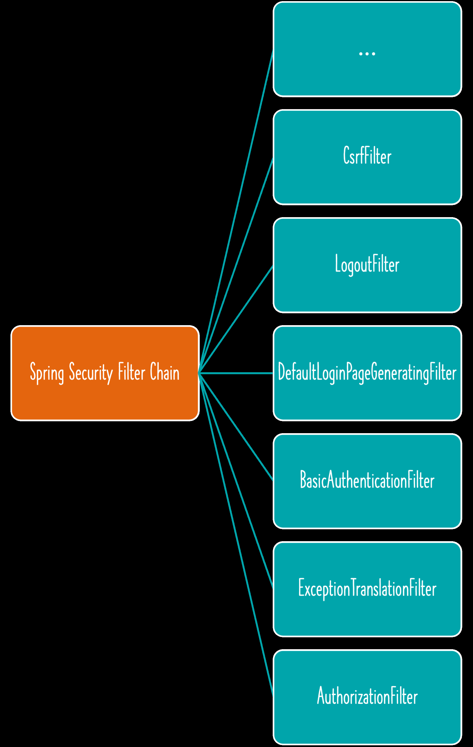

You intercept all request with Spring Security at filter level & then you can tell Spring security what your authentication/ authorization requirement is per url
Delegate filter proxy- catch all request & delegate to bunch of other Spring Security Specific filters

How Authentication Works in Spring Security?
There is authentication filter that intercepts authentication requests, & initiate the process of authentication.
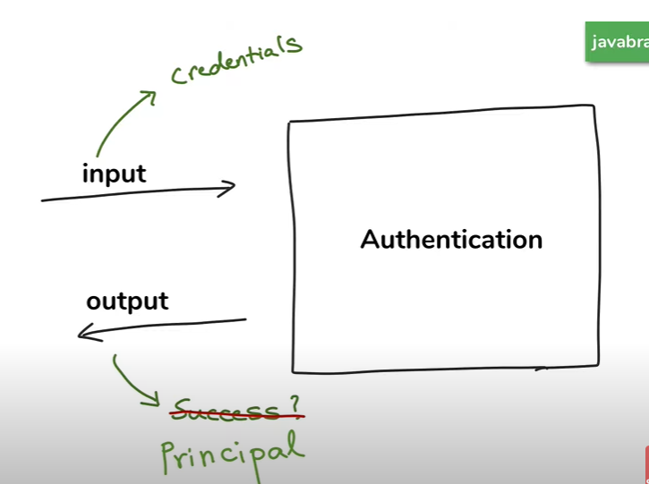
Authentication object hold credentials before login & once user authenticated hold Principal

Think of Authentication is data transfer object for authentication.

Providers –
